

PICO-EHL1 Rev A0.1_0_0

Jumper and Connector Settings

QIG

Released 2022/10/06
Function Block

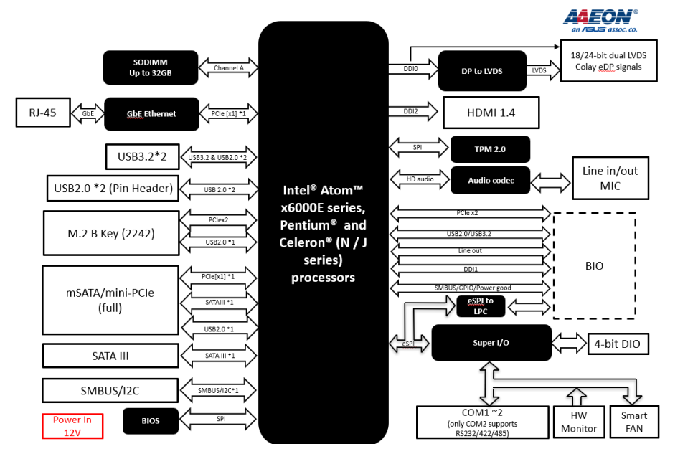
Board Layout:
TOP View:
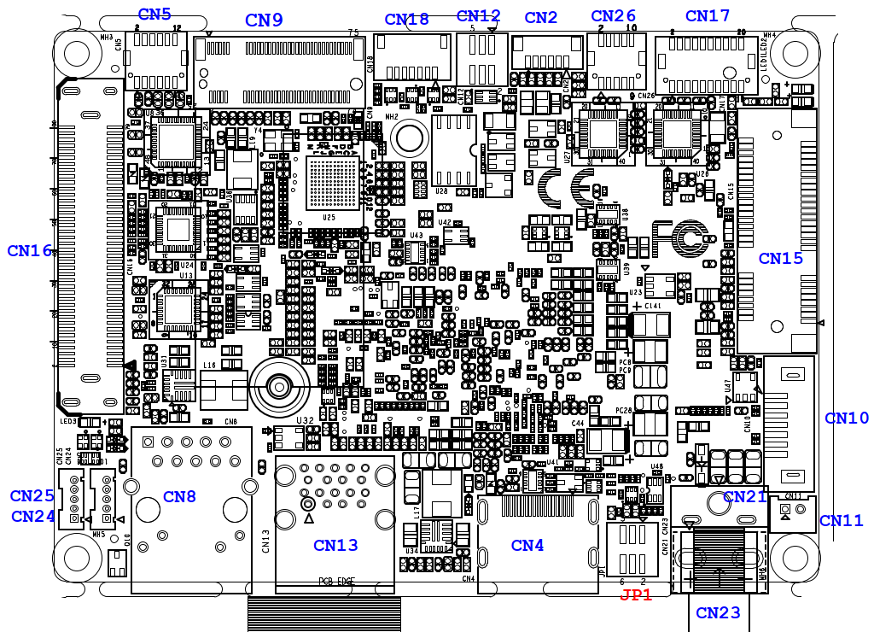

BOT View:
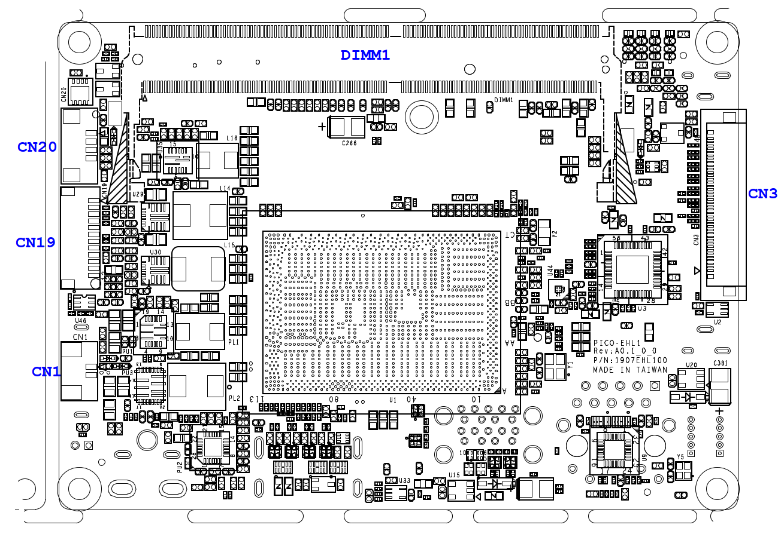

List of Jumpers
Jumpers allow users to manually customize system configurations to their suitable application needs.

The following chart consist the list of each jumper function:

Label | Function
JP1 | Clear CMOS Jumper & Auto Power Button Enable/Disable

(JP1) Clear CMOS Jumper & Auto Power Button Enable/Disable
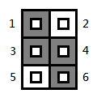
Clear CMOS Jumper
1-3 | Save CMOS | Default
3-5 | Clear CMOS

Auto Power Button Enable/Disable
2-4 | Disable
4-6 | Enable | Default

List of Connectors
Connectors on board access link to external devices such as hard disk drives, a keyboard.
Label | Function
CN1 | RTC Battery Connector
CN2 | LVDS Back Light Inverter
CN3 | LVDS/eDP [Reserved]
CN4 | HDMI
CN5 | AUDIO
CN8 | RJ45
CN9 | M.2 B-Key
CN10 | SATA
CN11 | SATA power
CN12 | 4 bit DIO
CN13 | USB3.0 Dual Port
CN15 | miniCard/mSATA
CN16 | BIO
CN17 | COM port (support 2 ports)
CN18 | SPI (For BIOS)
CN19 | Debug card/I2C/SMBUS
CN20 | 4 PIN FAN
CN21 | Power Input 12V
CN23 | DC Jack Power Input [Reserved]
CN24 | USB2.0 Connector
CN25 | USB2.0 Connector
CN26 | Front Panel
(CN1) RTC Battery Connector
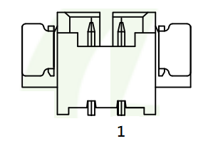
Pin | Pin Name | Signal Type | Signal level
1 | +3.3V | PWR | +3.3V
2 | GND | GND

(CN2) LVDS Back Light Inverter
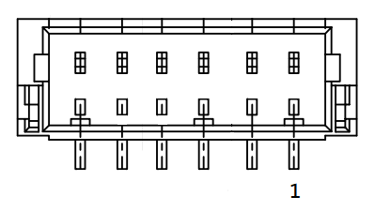
Pin | Pin Name | Signal Type | Signal level
1 | BLK_PWR | PWR | +12V (Default) / +5V
2 | BLK_PWR | PWR | +12V (Default) / +5V
3 | BKL_CONTROL | Signal
4 | GND | GND
5 | GND | GND
6 | BKL_ENABLE | Signal
Note: Backlight power can be 12V or 5V by BOM. Stuff R285 for 12V and stuff R287 for 5V. [Default:12V]
Note: CN2 power current max: 2A

(CN3) LVDS/eDP [Reserved]
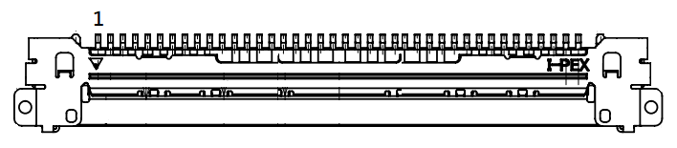
Pin | Pin Name | Signal Type | Signal level
1 | GND | GND
2 | LVD1_CB_3_DP | DIFF
3 | LVD1_CB_3_DN | DIFF
4 | GND | GND
5 | LVD1_CB_CLKP | DIFF
6 | LVD1_CB_CLKN | DIFF
7 | GND | GND
8 | LVD1_CB_2_DP | DIFF
9 | LVD1_CB_2_DN | DIFF
10 | GND | GND
11 | LVD1_CB_1_DP | DIFF
12 | LVD1_CB_1_DN | DIFF
13 | GND | GND
14 | LVD1_CB_0_DP | DIFF
15 | LVD1_CB_0_DN | DIFF
16 | GND | GND
17 | +V3P3S | PWR | +3.3V
18 | LVD1_DDC_CLK/  DDI0_HPD | Signal
19 | LVD1_BKLTEN/  DDI0_BKLTEN | Signal
20 | LVD1_DDC_DATA | Signal
21 | LVD1_BKLCTL/  DDI0_BKLTCTL | Signal
22 | GND | GND
23 | LVD1_CA_CLKP/ DDI0_AUX_DP | DIFF
24 | LVD1_CA_CLKN/  DDI0_AUX_DN | DIFF
25 | GND | GND
26 | LVD1_CA_3_DP/  DDI0_LANE3_DP | DIFF
27 | LVD1_CA_3_DN/  DDI0_LANE3_DN | DIFF
28 | GND | GND
29 | LVD1_CA_0_DP/  DDI0_LANE0_DP | DIFF
30 | LVD1_CA_0_DN/  DDI0_LANE0_DN | DIFF
31 | GND | GND
32 | LVD1_CA_1_DP/  DDI0_LANE1_DP | DIFF
33 | LVD1_CA_1_DN/  DDI0_LANE1_DN | DIFF
34 | GND | GND
35 | LVD1_CA_2_DP/  DDI0_LANE2_DP | DIFF
36 | LVD1_CA_2_DN/  DDI0_LANE2_DN | DIFF
37 | GND | GND
38 | +VDD | PWR | +3.3V
39 | +VDD | PWR | +3.3V
40 | +VDD | PWR | +3.3V
Note: CN3: VDD power current max:1.5A.

(CN4) Dual HDMI
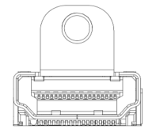
Pin | Pin Name | Signal Type | Signal level
1 | HDMI_TX2+ | DIFF
2 | GND | GND
3 | HDMI_TX2- | DIFF
4 | HDMI_TX1+ | DIFF
5 | GND | GND
6 | HDMI_TX1- | DIFF
7 | HDMI_TX0+ | DIFF
8 | GND | GND
9 | HDMI_TX0- | DIFF
10 | HDMI_CLK+ | DIFF
11 | GND | GND
12 | HDMI_CLK- | DIFF
13 | NC
14 | NC
15 | DDC_CLK | Signal | +5V
16 | DDC_DATA | Signal | +5V
17 | GND | GND
18 | +5V | PWR | +5V
19 | HDMI_HPD

(CN5) AUDIO
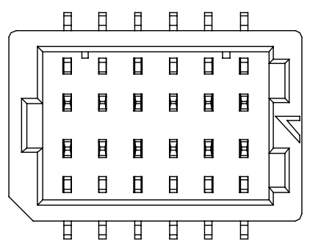
Pin | Pin Name | Signal Type | Signal level
1 | LOUT_R | Signal
2 | MIC_R | Signal
3 | LOUT_L | Signal
4 | MIC_L | Signal
5 | JD_LOUT | Signal
6 | JD_MIC | Signal
7 | AUD_GND | GND
8 | AUD_GND | GND
9 | JD_LIN | Signal
10 | LIN_R | Signal
11 | +V5A_AUD | PWR | +5V
12 | LIN_L | Signal
13 | AUD_GND | GND
14 | AUD_GND | GND
(CN8) RJ45
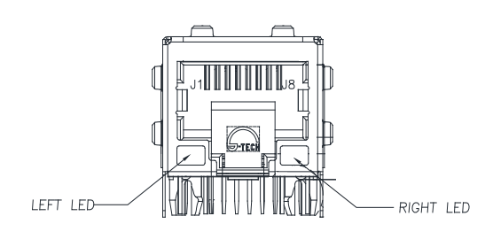

Pin | Pin Name | Signal Type | Signal level
P1 | LAN1_MDI0+ | DIFF
P2 | LAN1_MDI0- | DIFF
P3 | LAN1_MDI1+ | DIFF
P4 | LAN1_MDI1- | DIFF
P5 | LAN1_CT
P6 | LAN1_CT
P7 | LAN1_MDI2+ | DIFF
P8 | LAN1_MDI2- | DIFF
P9 | LAN1_MDI3+ | DIFF
P10 | LAN1_MDI3- | DIFF
2L2 | +V3P3A | VDD | +3.3V
2L3 | LAN2_LED_100# | Signal
2L4 | LAN2_LED_1000# | Signal
(CN9) M.2 B-Key
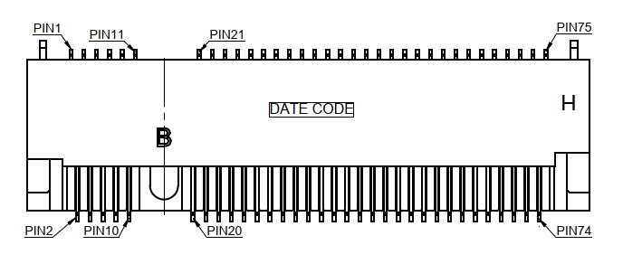
Pin | Pin Name | Signal Type | Signal level
1 | GND | GND
2 | +V3P3A | PWR | 3.3V
3 | GND | GND
4 | +V3P3A | PWR | 3.3V
5 | GND | GND
6 | FULL_CARD_PWR_OFF
7 | USB2_4_DP | DIFF
8 | W_DISABLE2# | Signal
9 | USB2_4_DN | FIFF
10 | SSD_LED# | Signal
11 | GND
20 | NC
21 | GND
22 | NC
23 | NC
24 | NC
25 | NC
26 | NC
27 | GND
28 | NC
29 | PCIE_5_RXN | DIFF
30 | NC
31 | PCIE_5_RXP | DIFF
32 | NC
33 | GND | GND
34 | NC
35 | PCIE_5_TXP | DIFF
36 | NC
37 | PCIE_5_TXN | DIFF
38 | NC
39 | GND | GND
40 | NC
41 | PCIE_4_RXP | DIFF
42 | NC
43 | PCIE_4_RXN | GND
44 | NC
45 | GND | GND
46 | NC
47 | PCIE_4_TXN | DIFF
48 | NC
49 | PCIE_4_TXP | DIFF
50 | BUF_PLT_RST# | Signal
51 | GND | GND
52 | PCIE_CLKREQ#0 | Signal
53 | PCIE_0_CLK_DN | DIFF
54 | PCIE_WAKE# | Signal
55 | PCIE_0_CLK_DP | DIFF
56 | NC
57 | GND | GND
58 | NC
59 | NC
60 | NC
61 | NC
62 | NC
63 | NC
64 | NC
65 | NC
66 | NC
67 | NC
68 | NC
69 | GND | GND
70 | +V3P3A_2242 | PWR | 3.3V
71 | GND | GND
72 | +V3P3A_2242 | PWR | 3.3V
73 | GND | GND
74 | +V3P3A_2242 | PWR | 3.3V
75 | NC

(CN10) SATA
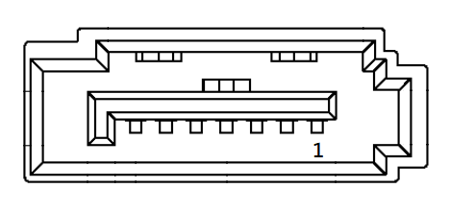
Pin | Pin Name | Signal Type | Signal level
1 | GND | GND
2 | SATA_1_TXP | DIFF
3 | SATA_1_TXN | DIFF
4 | GND | GND
5 | SATA_1_RXN | DIFF
6 | SATA_1_RXP | DIFF
7 | GND | GND

(CN11) SATA Power
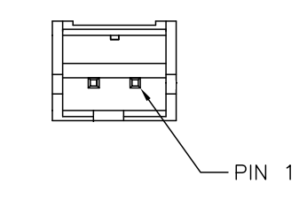
Pin | Pin Name | Signal Type | Signal level
1 | +V5S | VDD | 5V
2 | GND | GND
Note: CN7 SATA power current max: 1.5A.

(CN12) 4-bit DIO Header
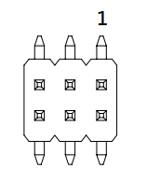
Pin | Pin Name | Signal Type | Signal level
1 | +V5S | VDD | 5V
2 | DIO_0 | Signal
3 | DIO_1 | Signal
4 | DIO_2 | Signal
5 | DIO_3 | Signal
6 | GND | GND
Note: CN8 DIO power current max: 0.5A.

(CN13) USB3.0 Connector [Support 2 ports]
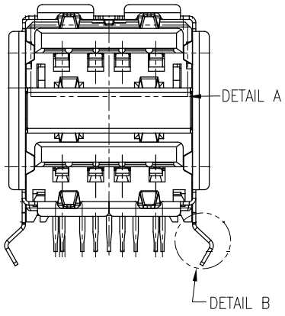
Pin | Pin Name | Signal Type | Signal level
1 | +V5A_USB12 | PWR | +5V
2 | USB2_0_DN | DIFF
3 | USB2_0_DP | DIFF
4 | GND | GND
5 | USB3_0_RXN | DIFF
6 | USB3_0_RXP | DIFF
7 | GND | GND
8 | USB3_0_TXN | DIFF
9 | USB3_0_TXP | DIFF
10 | +V5A_USB12 | PWR | +5V
11 | USB2_1_DN | DIFF
12 | USB2_1_DP | DIFF
13 | GND
14 | USB3_1_RXN | DIFF
15 | USB3_1_RXP | DIFF
16 | GND
17 | USB3_1_TXN | DIFF
18 | USB3_1_TXP | DIFF
(CN15) mSATA/mini-Card
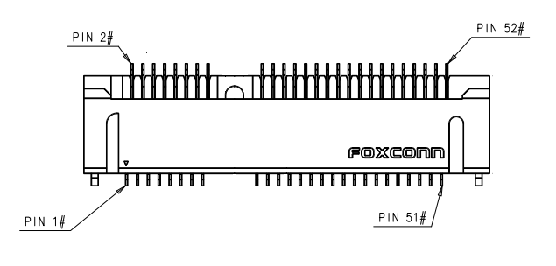
Pin | Pin Name | Signal Type | Signal level
1 | PCIE_WAKE# | Signal
2 | +3.3V | PWR | +3.3V
3 | NC
4 | GND | GND
5 | NC
6 | +1.5V | PWR | +1.5V
7 | PCIE_CLK_REQ# | Signal
8 | NC
9 | GND | GND
10 | NC
11 | PCIE_REF_CLK- | DIFF
12 | NC
13 | PCIE_REF_CLK+ | DIFF
14 | NC
15 | GND | GND
16 | NC
17 | NC
18 | GND | GND
19 | NC
20 | W_DISABLE# | Signal | +3.3V
21 | GND | GND
22 | PCIE_RST# | Signal | +3.3V
23 | PCIE_RX-/SATA_RX+ | DIFF
24 | +3.3V | PWR | +3.3V
25 | PCIE_RX+/SATA_RX- | DIFF
26 | GND | GND
27 | GND | GND
28 | +1.5V | PWR | +1.5V
29 | GND | GND
30 | SMB_CLK | Signal | +3.3V
31 | PCIE_TX-/SATA_TX- | DIFF
32 | SMB_DATA | Signal | +3.3V
33 | PCIE_TX+/SATA_TX+ | DIFF
34 | GND | GND
35 | GND | GND
36 | USB_D- | DIFF
37 | GND | GND
38 | USB_D+ | DIFF
39 | +3.3V | PWR | +3.3V
40 | GND | GND
41 | +3.3V | PWR | +3.3V
42 | NC
43 | GND | GND
44 | NC
45 | NC
46 | NC
47 | NC
48 | +1.5V | PWR | +1.5V
49 | NC
50 | GND | GND
51 | NC
52 | +3.3V | PWR | +3.3V
(CN16) BIO
Pin | Pin Name | Signal Type | Signal level
1 | +V12A | PWR | +12V
2 | GND | GND
3 | GND | GND
4 | PCIE_0_TXN | DIFF
5 | PCIE_0_RXN | DIFF
6 | PCIE_0_TXP | DIFF
7 | PCIE_0_RXP | DIFF
8 | GND | GND
9 | GND | GND
10 | PCIE_1_TXN | DIFF
11 | PCIE_1_RXN | DIFF
12 | PCIE_1_TXP | DIFF
13 | PCIE_1_RXP | DIFF
14 | GND | GND
15 | GND | GND
16 | PS_ON# | Signal
17 | DDI1_CTRL_CLK
18 | DDI1_CTRL_DATA
19 | +V5A | PWR | +5V
20 | +V5A | PWR | +5V
21 | +V5A | PWR | +5V
22 | +V5A | PWR | +5V
23 | PCIE_1_CLK_DP | DIFF
24 | BUF_PLT_RST# | Signal
25 | PCIE_1_CLK_DN | DIFF
26 | GND | GND
27 | GND | GND
28 | DDI1_LANE1_DN | DIFF
29 | DDI1_LANE0_DN | DIFF
30 | DDI1_LANE1_DP | DIFF
31 | DDI1_LANE0_DP | DIFF
32 | GND | GND
33 | GND | GND
34 | DDI1_LANE3_DN | DIFF
35 | DDI1_LANE2_DN | DIFF
36 | DDI1_LANE3_DP | DIFF
37 | DDI1_LANE2_DP | DIFF
38 | GND | GND
39 | GND | GND
40 | DDI1_HPD_BIO | Signal
41 | DDI1_AUXN | DIFF
42 | GND | GND
43 | DDI1_AUXP | DIFF
44 | USB3_2_TXN | DIFF
45 | GND | GND
46 | USB3_2_TXP | DIFF
47 | USB2_6_DN | DIFF
48 | GND | GND
49 | USB2_6_DP | DIFF
50 | USB3_2_RXN | DIFF
51 | GND | GND
52 | USB3_2_RXP | DIFF
53 | SMB_CLK
54 | GND | GND
55 | SMB_DATA
56 | PCIE_WAKE# | Signal
57 | GND | GND
58 | USB2_OC2# | Signal
59 | +5V | PWR | +5V
60 | USB 2.0_OC# | Signal
61 | +5V | PWR | +5V
62 | +5V | PWR | +5V
63 | +5V | PWR | +5V
64 | +5V | PWR | +5V
65 | LPC_AD0 | Signal
66 | LPC_FRAME# | Signal
67 | LPC_AD1 | Signal
68 | SERIRQ# | Signal
69 | LPC_AD2 | Signal
70 | NC
71 | LPC_AD3 | Signal
72 | GPIO | Signal
73 | GND | GND
74 | Audio_GND | GND
75 | LPC_CLK | Signal
76 | Audio_OUT_L | Signal
77 | PME# | Signal
78 | Audio_OUT_R | Signal
79 | GND | GND
80 | GND | GND

(CN17) COM Header [Support 2 ports]
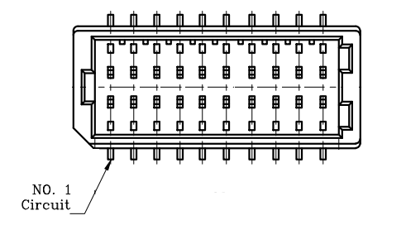
Pin | Pin Name_RS232 | Pin Name_RS422 | Pin Name_RS485
1 | DCD_1 | TX_1- | DATA_1-
2 | DCD_2 | TX_2- | DATA_2-
3 | RX_1 | TX_1+ | DATA_1+
4 | RX_2 | TX_2+ | DATA_2+
5 | TX_1 | RX_1+
6 | TX_2 | RX_2+
7 | DTR_1 | RX_1-
8 | DTR_2 | RX_2-
9 | GND | GND | GND
10 | GND | GND | GND
11 | DSR_1
12 | DSR_2
13 | RTS_1
14 | RTS_2
15 | CTS_1
16 | CTS_2
17 | RI_1/12V/5V
18 | RI_2/12V/5V
19 | UART_TX
20 | UART_RX
※ COM RS-232/422/485 can be set by BIOS setting. Default is RS-232.
※ RI1/+5V/+12V function can be set by BOM(R423-RI/R369-+12V/R370-+5V). Default is RING.
※ RI2/+5V/+12V function can be set by BOM(R424-RI/R372-+12V/R373-+5V). Default is RING.
Note: CN17 COM power current max: 0.5A for each port.
(CN18) SPI
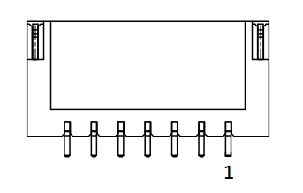
Pin | Pin Name | Signal Type | Signal level
1 | SPI_SO | Signal
2 | GND | GND
3 | SPI_CLK | Signal
4 | +V3P3A_SPI | PWR | 3.3A
5 | SPI_SI | Signal
6 | SPI_CS | Signal
7 | NC

(CN19) eSPI(Debug card)/SMbus/I2C
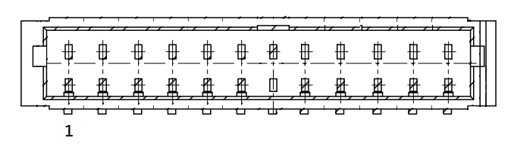
Pin | Pin Name | Signal Type | Signal level
1 | ESPI_IO0 | Signal | +1.8V
2 | ESPI_IO1 | Signal | +1.8V
3 | ESPI_IO2 | Signal | +1.8V
4 | ESPI_IO3 | Signal | +1.8V
5 | +V3.3S | PWR | +3.3V
6 | ESPI_CS | Signal
7 | ESPI_RESET# | Signal | +1.8V
8 | GND | GND
9 | ESPI_CLK | Signal | 1.8V
10 | SMB_DATA/ I2C_SDA | Signal | +3.3V
11 | SMB_CLK/ I2C_CLK | Signal | +3.3V
12 | SMB_ALERT/ INT_SERIRQ | Signal | +3.3V
(CN20) 4-pin Smart FAN
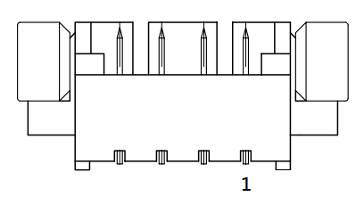
Pin | Pin Name | Signal Type | Signal level
1 | GND | GND
2 | +V12S | PWR | +12V
3 | FAN_TAC | Signal
4 | FAN_CTL | Signal
Note: CN19 Smart FAN power current max: 1.0A.

(CN21) Power Input 12V
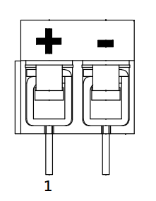
Pin | Pin Name | Signal Type | Signal level
1 | +V_IN | PWR | +12V
2 | GND | GND

(CN23) DC Jack Power Input [Reserved]
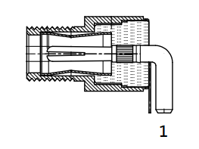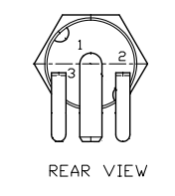
Pin | Pin Name | Signal Type | Signal level
1 | +V_IN | PWR | +12V
2 | GND | GND
3 | GND | GND

(CN24/25) USB2.0 Connector
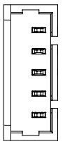
Pin | Pin Name | Signal Type | Signal level
P1 | +V5A | PWR | 5V
P2 | USB2_DN | DIFF
P3 | USB2_DP | DIFF
P4 | GND | GND
P5 | GND | GND
(CN26) Front Panel
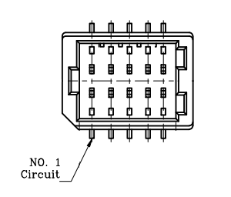
Pin | Pin Name | Signal Type | Signal level
1 | GND | GND
2 | EXT_PWRBTN# | Signal
3 | FP_IDELED# | Signal
4 | +V3P3S | PWR | +3.3V
5 | FP_BUZZER | Signal
6 | +V5S | PWR | +5V
7 | GND
8 | +V3P3S | PWR | +3.3V
9 | GND
10 | HWRST# | Signal

List of mating connectors and cables:

Note 1 : eDP Test Panel: B173ZAN01.0-AUO & LVDS Test Panel: G121XN01V0-AUO
Connector  Label | Function | Mating Connector |  | Available Cable | AAEON Cable P/N
Connector  Label | Function | Vendor | Model no | Available Cable | AAEON Cable P/N
CN1 | RTC Battery | Molex | 51021-0200 | Battery Cable | 175011301C
CN2 | LVDS Back Light Inverter | SHR | WL1010H-6P  Terminal: KB901-10T | LVDS Inverter Cable | 170X000152
CN3 | LVDS | I-PEX | 20453-040T-11 | LVDS Cable | 170X000532
CN3 | EDP | I-PEX | 20453-040T-11 | EDP Cable | 170X000531
CN10 | SATA | Molex | 887505318 | SATA Cable | 1709070500
CN11 | SATA Power | JST | PHR-2 | SATA Power Cable | 1702150155
CN12 | 4-bit DIO Header | PINREX | 633-92-03GB00 | N/A | N/A
CN17 | COM Header | JST | SHDR-20V-S-B | COM Port Cable | 170X000231
CN19 | eSPI/SMBUS/I2C | JST | SHR-12V-S-B | LPC/eSPI Cable | 1703120130
CN20 | 4-pin Smart FAN | Molex | 51021-0400 | N/A | N/A
CN21 | Power Input | Molex | 19211-0003 | Power Cable | 170204010R
CN23 | DC Jack Power Input | HUANG JI | 5525C257-3T00-R1-7.5 | Power Cable | 1702041004
CN24/25 | USB2.0 Header | Molex | 51021-0500 | USB2.0 Cable | 1700050207
CN26 | Front Panel | ACES | 50247-010H0H0-001 | Front Panel Cable | 1709100108
Note 2:
170X000531 (TF)EDP Cable.40P.with AUO B173ZAN01.0.300mm.UC Function.UC-W037.For PICO-EHL4 A1.1
170X000532 (TF)LVDS Cable.40P.with AUO G121XN01V0.350mm.UC Function.UC-W038.For PICO-EHL4 A1.1

